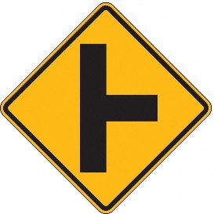Watch for side road traffic to the right

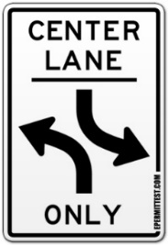 The center lane is used for left turns only

 Turn left from either lane

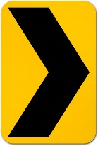 Watch for road curving to right

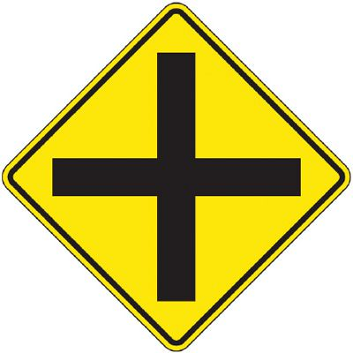Watch right and left for other traffic

Drive to the right

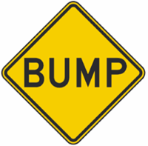Slow down for a sharp rise in the roadway

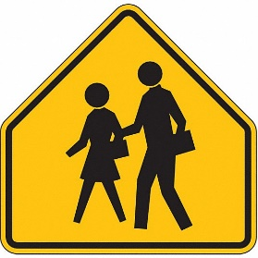Drive slow and watch out for children

Be sure to stay well in your land because the bridge ahead has room for only two lanes of traffic

Watch for a drop from pavement edge to the shoulder

Be extra careful not to run off of the pavement

Expect a change in the road surface

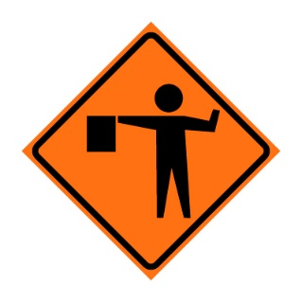Watch for a construction or maintenance project ahead

Watch for trucks entering or crossing the highway

Know that Texas Highway 235 runs right and left ahead

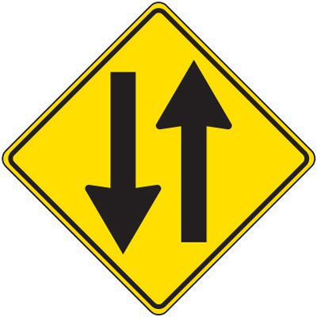Get ready to enter a two-way street

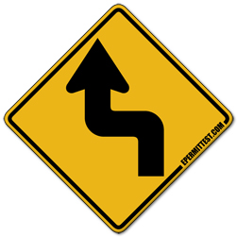Slow down for a left and right turn

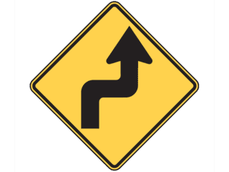Slow down for a right and left turn

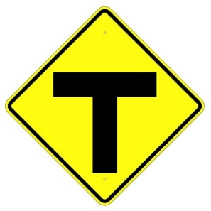Watch right and left for cross traffic

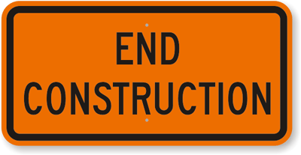Construction is ending

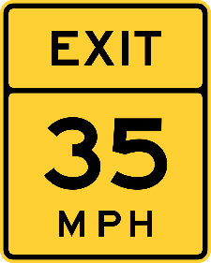Slow to 35 miles per hour to exit expressway

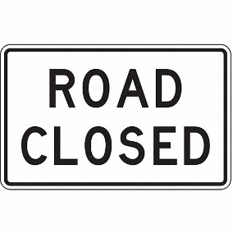Look for a detour or turn around and go back

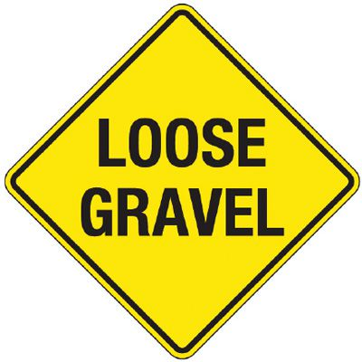Do not apply brakes suddenly or make sharp turns

Stop only in an emergency, such as vehicle failure

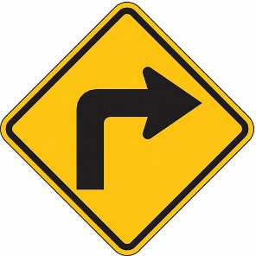Slow down for a turn to the right

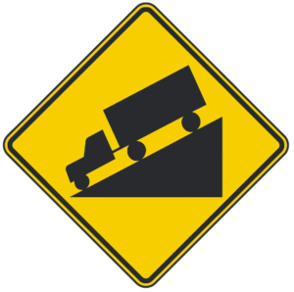Prepare to reduce speed for a downgrade

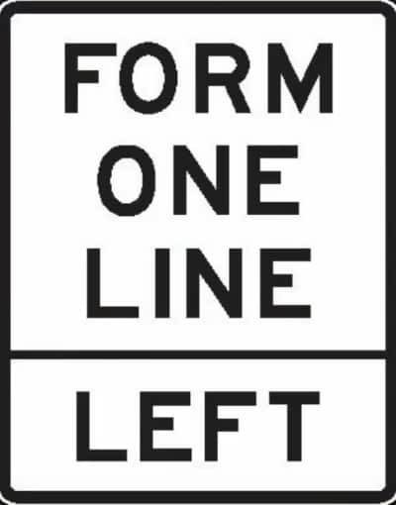Prepare to merge into only one lane of traffic

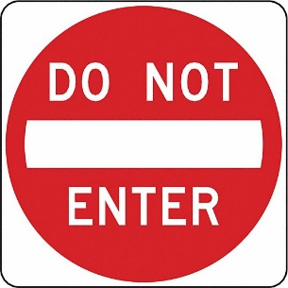Get ready to turn right or left

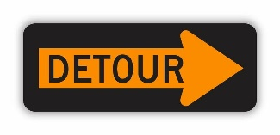Watch for a temporary route around the main road

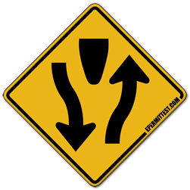Stay on the right-hand side of the road and watch approaching traffic

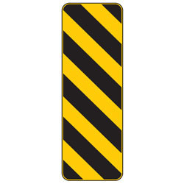Be careful not to sideswipe a solid object which this sign marks

Watch for a very dangerous crossing

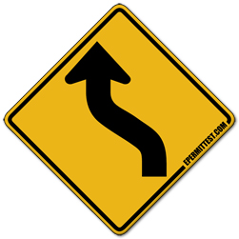Slow down for a left and right curve

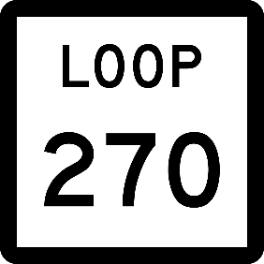Understand that you are on a short state highway in a city or urban area

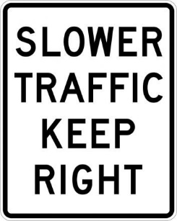Keep in the right-hand lane when driving slow

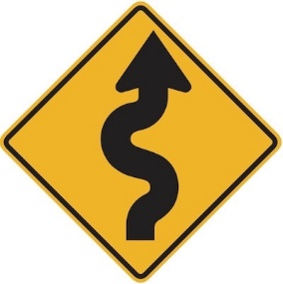Slow down for a winding road

Go straight ahead or turn right

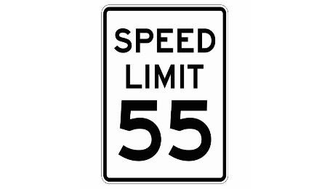Drive no faster than 55 miles per hour day or night

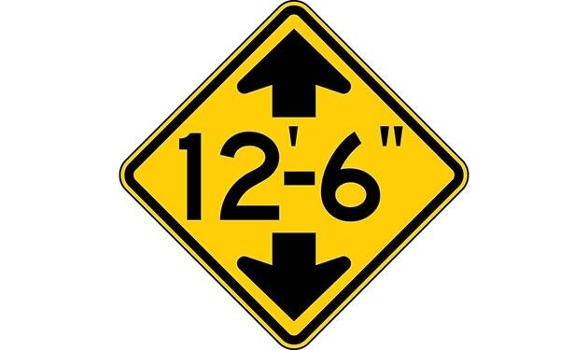Be sure your load will go under a bridge or underpass ahead

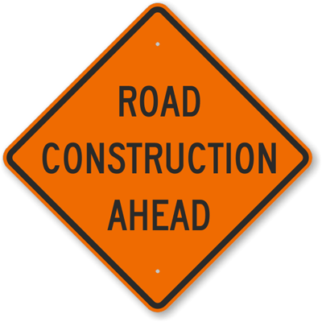Watch for machinery and workers

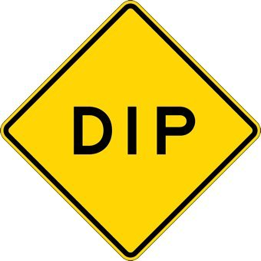Slow down for a low place in the road

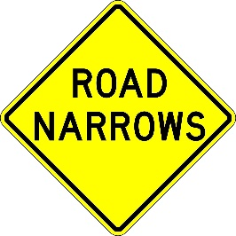The pavement ahead narrows

Slow down, watch for people crossing the street on foot

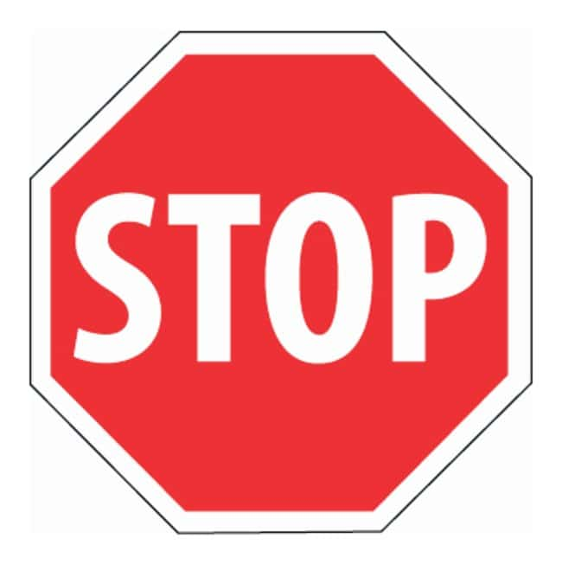Always stop completely

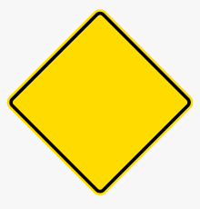Watch for a hazard in or near the roadway

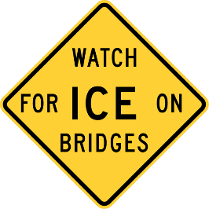Slow down – a hazardous condition may exist on bridge

 Never pass another vehicle at this location

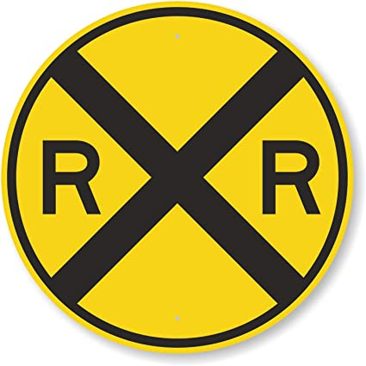Look out for a train

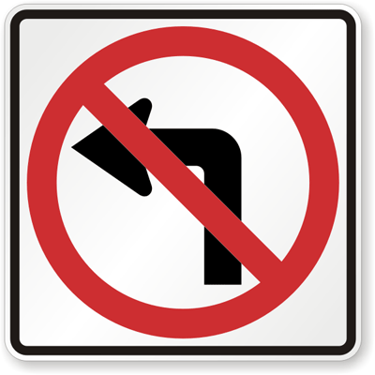Left turns are prohibited at this intersection

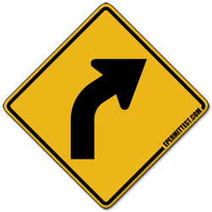Slow down for a right curve

Yield to other traffic

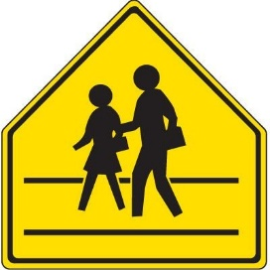Drive slow and watch out for children